Bright Ideas in Health Awards 2015 – Innovation in Primary Care Category

Oxford Terrace and Rawling Road Medical Group
Managing Frailty in the Community Though Personalised Care Planning

The idea
Managing Frailty in the Community Though Personalised Care Planning

Describe the unmet need or problem the innovation addresses in primary care

Oxford Terrace and Rawling Road Medical Group (OTMG-RR) is a GP practice, situated in Central Gateshead. The population of about 15,200 patients is predominantly deprived, with high numbers of refugees and asylum seekers. We have a particular passion for patients with complex care needs and using a risk stratification tool we identified that about 2500 of our patients with multiple comorbidities were at high risk of being admitted to hospital. 100 of these patients were house bound and did not meet the criteria for access to community matrons. Despite having community matrons attached to the practice our trajectory for attendances and admissions to hospital were increasing.
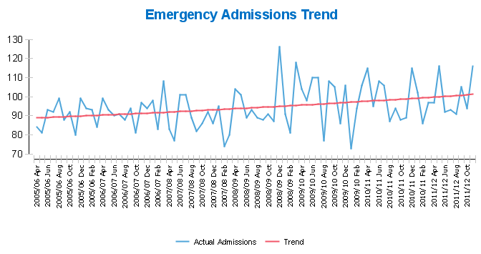

Describe the solution and how it works
An experienced Older Persons Specialist Nurse (OPSN) was recruited by South Tyneside NHS Foundation Trust and released on secondment to implement the principles of Comprehensive Geriatric Assessment to achieve continuity of care for elderly patients with complex health and social care needs.
What is the benefit of this innovation over current methods or products used?
What is the current status of the innovation?

In the first 8 months of this project to May 31st 2014 , 94 housebound patients with an Average Age of 85 years ,were referred to the OPSN and had care planned and implemented, using the principals of Comprehensive Geriatric Assessment .
This role was based directly within the practice and provided the benefits of co-production with the core members of the PHCT, patients and their carers working as equals in collaboration to optimise the health and well- being of frail older people. Equally, there were rewards to the practice in terms of opportunities for peer support; networking and sharing, and multi-disciplinary working. The appointment of a Nurse Specialist as a clinical leader with knowledge and skills in the care of older people, wide experience of effective multi-disciplinary and interagency working and awareness of the local and national drivers affecting the care of older people was a key component in the success of this.
Referrals in First 8 Months
Referred female patients | 62 | 67%
Referred male patients | 32 | 33%

Place of Residence | Numbers | % | Comments
Own Home | 83 | 88% | Largely housebound population Equally 53 carers / family members were actively supported by the OPSN
Assisted Living Scheme | 17 | 18% | e.g.Housing 21, LA Schemes with on site carers / facilities.  Potential for use of on site proactive clinics if numbers attached were significant enough
Sheltered Accommodation | 4 | 4% | General schemes without on-site carers

Referral Sources
Referrer | Number | % | Comments
General Practitioner | 37 | 39% | 10 GP’s within the practice made direct referrals to OPSN
Practice Based Nurse Practitioner | 19 | 20% | Referrals from 2 Nurses within the practice
Proactive Casefinding | 25 | 26% | Conducted in initial month of project , focusing on over 80 years - cross referencing against the Housebound Flu list , previous 6 month housecall requests and RADIAR
Self / Carer | 5 | 5% | 2 - HCP ‘s aware of OPSN role re: family members  2 – spouses of patients on caseload  1 – spouse stopped OPSN in corridor of sheltered accom.

This post has become substantive in the practice. In addition, we have negotiated with our community services providers to have our community matron directly linked to the practice, making her more visible, available and a core part of our multi-disciplinary working. innovation has enabled us to strengthen the nursing team with the right skills. She also use the practice clinical reporting system to ensure patient safety through improved communication.
Evidence
Is there any evidence to demonstrate the effectiveness of the innovation?
Very early in this project the outcomes were reassuring, showing a downward trend in the use of several aspects of unscheduled care and home visits.

Use of Unscheduled Care Findings in First Nine Months of Project
Unscheduled Care | 9 months Pre Project | Post Project | Comments
A&E Attendance | 66 | 30  54% reduction
Admissions | 63 | 29  54% reduction | 3 people were directly admitted by the OPSN – 2 to EAU and 1 to St Bede Unit directly for End of Life care.
House Call  requests | 318 | 63 – 81% reduction

In addition:
- All patient’s on the case load had a comprehensive care plan that was uploaded onto the adastra system for external organisations to enable integrated working;
- 53 carers were identified and also received support and were signposting to appropriate services;

Are you aware of any companies/CCGs who deliver similar products or service innovations?
Similar interventions are normally provided through community services providers. However, access to these services is challenging as they are neither available nor visible in the practice. They have a reactive approach and referral criteria tend to exclude the group of patients we were targeting for this intervention. There is no incentive to manage these people proactively in general practice, other than the annual review required through the quality and outcomes framework. This is a process measure that evidences little improvement to outcomes for patients. With this intervention we aimed to move beyond the qof, to manage patients proactively in their own homes.

Has your idea been disclosed to others?
Yes, though learning and sharing events. Gateshead CCG has used this intervention to inform commissioning of future community services and it has informed service developments for the £5 per head funding recently allocated to practices to support patient’s out of hospital.

Describe any challenges that may need to be overcome to further develop and/or implement your idea
- Reluctance of community service providers to base staff in GP practices and correspondingly the lack of accommodation for community staff to be based in practices;
- The mind-set of nurses and others working in general practice/community services and their desire to change;
- Capacity and capability in general practice to support this type of change
- Workforce pressures to free staff to become involved and undertake adequate measurement;
- Lack of training to support the needs of people with complex care needs and frailty.

Which other organisations have been involved with the development/implementation of your idea?
The initiative was led by Sheinaz Stansfield Practice Manager. She was supported by all the staff and partners at Oxford Terrace and Rawling Road Medical Group, Mrs Lesley Bainbridge, Angus McLennan, and Lynn Shaw from South Tyneside NHSFT: Community Services were involved. There was involvement and support from the Director of Adult services from Gateshead Council, the Urgent Care Lead from Gateshead CCG also was also involved with the support of the CCG Executive.

Adoption and sharing best practice
This intervention is easily replicable and has been shared with Gateshead CCG to inform future commissioning of community services.

Are you aware of anyone conducting research or trying to solve the same problem?
If so, who?
I am not aware of any formal research, however, Gateshead CCG have used this to inform commissioning of community services. In addition, practices in Gateshead have used the outcomes for service developments for the national £5 per head initiative, to manage complex care and reduce attendances and admissions through A&E.

Should this idea go further, would you be prepared to invest your time in its development?
Yes it needs to go further, if we are to manage workforce challenges and improve integration of services around patient need. In addition the skills set for practice nurses will have to change going forward, to manage the long term conditions tsunami and demographic changes and frailty that lie ahead. The emergent impact of frailty being classified as a long term condition will also require nurses to work differently and move away from task based care to personalised care planning. The approach we have taken has enabled us to become early adopters and inform commissioning of community services. The ideas are easily replicable with limited resource. There is also an urgent need to do this.

